Managing child safety in church

Contents

1. Introduction 2
2. References 2
3. Child safe policy 3
4. Risk assessments and self-evaluation 3
5. Selection, screening and training 4
6. Addressing concerns, suggestions, and non-reportable conduct 7
7. Addressing unacceptable or reportable conduct 8
8. Procedures relating to a ‘person of concern’ 14
9. Record keeping 14
10. Related policy and procedures 15
Appendix 1 – Child Safe Standards 16

Introduction

Lighthouse Church is committed to creating and maintaining an environment that ensures the safety and wellbeing of everyone involved, but particularly children and other vulnerable people.

Children can expect to be safe and protected, to be respected and listened to, and to have their particular needs addressed in church activities. We are committed to developing and implementing a safe culture that supports the prevention and reporting of risk and abuse.

This primary audience for this document is the Head of Relevant Entity (Senior Pastor), other staff, and safe ministry representatives. Secondary audience is other paid staff and children/youth ministry leaders. This document outlines Lighthouse Church’s child safe policy and procedures in relation to:
- developing, implementing and maintaining a child safe culture and systems
- addressing the Child Safe Standards and meeting our legislative obligations
- selection, screening and training of children/youth ministry workers
- reporting procedures for unacceptable behaviour.

A separate related document, LC04 – serving in children’s/youth ministry is designed specifically for children’s/youth ministry workers and leaders.

References

Legislation
- Child Protection (Working with Children) Act 2012
- Child Protection (Working with Children) Regulation 2013
- Children’s Guardian Act 2019.

In legislation ‘the paramount consideration in administering, operating and making decisions under the Act is the safety, welfare and wellbeing of children, including protecting children from child abuse’ (known as the paramountcy principle).

NSW government information
- Office of the Children’s Guardian
- Guide to the Child Safe Standards
- Implementing the Child Safe Standards - a Guide for Faith-Based Organisations
- Codes of Conduct: a guide to developing child safe Codes of Conduct
- Department of Communities and Justice
- NSW government Child Story reporter
- NSW Reportable Conduct Scheme factsheets
Church based organisations
- Sydney Anglican Network's Safe Ministry Resources
- Safe Ministry Blueprint for Churches https://safeministry.org.au/safety-plans/
- Guidelines for parishes regarding persons of interest https://safeministry.org.au/safety-plans/
- Safe Ministry Training http://safeministrytraining.com.au
- Safe Ministry (Youthworks) training resources
- National Council of Churches in Australia (NCCA) www.ncca.org.au

Child safe policy
Our Safe Ministry Child Safe policy is designed to provide information for children, families, members, visitors and our community about our commitment to child safety, what they can expect from us, and how they can get more information or report concerns. The policy was developed using the Office of the Children’s Guardian (OCG) ‘Child Safe Child Friendly Policy’ template. The policy is publicly available on our website: https://www.lighthouse.net.au/policies-and-procedures/

Safe ministry responsibilities

Responsibilities for staff, Safe Ministry Representatives, children’s/youth ministry leaders and workers are outlined in detail in the document LC04 – serving in children’s/youth ministry.

In summary, the ‘head of relevant entity’ (HRE) who is ‘usually the entity’s most senior officer and the person who is primarily responsible for executive decision making in the organisation’ is ultimately responsible for developing a ‘child safe’ culture and systems and ensuring we meet our obligations in relation to screening and training ministry workers, and reporting unacceptable conduct and/or children at risk of harm or abuse. Safe Ministry Representatives may assist the HRE with day-to-day aspects of safe ministry, however statutory responsibilities of the HRE cannot be delegated.

Risk assessments and self-evaluation

Our general risk management approach is documented in LC07 Policy and procedure – work health and safety. In addition, we use the NSW Office of the Children’s Guardian (OCG) risk management resources:
- Risk Management and the Child Safe Standards: Part 1: Responding to risk and
- Risk Management and the Child Safe Standards Part 2: Identifying risk
In relation to child safety, we consider the following risk types or categories that could occur within our programs, events or services:
- accidental harm eg high risk activity or environment
- physical eg physical punishment, pushing, hitting
- sexual eg grooming, inappropriate relationship, conversation (including online) or physical contact
- psychological eg bullying or shaming (including online), isolating, spiritual abuse, discrimination
- neglect eg lack of supervision, inadequate care.

In general risk assessments are updated annually or whenever there is a significant change, and for new significant activities or events. In addition, we conduct an annual self-assessment against the Child Safe Standards (see Appendix 1) and the OCG Guidelines to the Child Safe Standards

The outcome of our risk assessment and self-evaluation process informs and supports our efforts to implement child safe culture, systems (policies and procedures) and practices across all areas of ‘work’.

Selection, screening and training

To ensure the safety of children and vulnerable people in our communities, Lighthouse Church will carefully select, screen and train those involved in children’s and youth ministry. These following procedures have been developed with reference to legislative and insurance requirements.

5.1 Process for children’s and youth ministry workers
Selection

Desirable characteristics for a children’s/youth ministry worker include someone who:
- has a growing, committed relationship with Christ
- believes children and young people are important to God
- respects and loves children and young people
- models godliness
- is teachable
- is reliable
- is willing and able to work as part of a team
- is open in their actions and behaviour
- is wise and careful.

Prior to selecting a potential new child/youth ministry worker, to provide an opportunity to assess and consider the above characteristics (and to meet our insurance obligations), a person must:
- have attended Lighthouse Church regularly for at least three months, and
- have completed Lighthouse Church’s membership process (which includes approval by Administration Committee) before being selected for ministry
- confirm they are willing to complete the necessary screening and training process.

Screening and training
Lighthouse Church will ensure children’s/youth ministry workers are screened in accordance with
requirements in the Child Protection (Working with Children) Act 2012 and Child Protection (Working
with Children) Regulation 2013 BEFORE commencing in any child related role whether in a paid or volunteer capacity.

Our screening and training process is outlined below:

- Send instruction sheet

An instruction sheet is emailed to the person so they can work through the screening and training process independently. If they do not have access to a computer, the instructions provide information about an option for completing the application by phone.

Legislation provides exemptions for some people from screening. Exemptions most likely to be relevant to Lighthouse Church include:
- under 18 years
- co-worker or supervisor of a child (eg music team if youth are team members)
- admin workers if work does not usually involve contact with children for extended periods
- work for a period of not more than a total of 5 working days in a calendar year, if the work involves minimal direct contact with children or is supervised when children are present
- parent, or close relative, of a child when volunteering in a group, program or activity of which the child is a member or in which the child usually participates (eg parent helpers volunteering in kids church) although this exemption does not apply if the work involves intimate contact (eg personal care), formal mentoring or attending an overnight camp
- visiting speaker, performer, assessor or other similar visitor if the work of the person at that place is for a one-off occasion and is carried out in the presence of one or more other adults.

If the leader identifies a person as likely to be exempt from the screening process, this must be confirmed with a safe ministry representative. The safe ministry representative will confirm the exemption by email for the purposes of record keeping.

- Person completes screening process

This involves a two part application process:
- completing the Working with Children (WWC) application form (online or by phone)
- attending a Service NSW centre to verify identity documentation. .

The WWC check obtains applicants’ national criminal histories from CrimTrac. Records include convictions (spent or unspent), charges (whether heard, unheard or dismissed) and juvenile records.

The Child Protection (Working with children) Act 2012 (Schedule 2) lists disqualifying offences that prevent a person working with children. Once a person has completed this process they will receive notification by email (or by post if application completed by phone).

Note: the person is NOT able to commence child related work at this point.

- Complete online safe ministry training

Lighthouse Church uses an external training provider - Safe Ministries - to provide online safe ministry training for children’s/youth ministry workers. The training provider developed the training package in consultation with ANSVAR, our insurer.

The instruction sheet and/or email invite sent by the ministry leader also provides the necessary information for the person to access the safe ministry training and independently complete the training once they have received their WWC number. Ministry workers must complete two modules – the Awareness course AND Leaders Course.

As part of the training process the person is also:
- asked to provide their WWC number to enable the training provider to complete the online employer verification process on behalf of Lighthouse Church
- asked to provide referee contact details to enable completion of reference checks
- required to declare if they have been the subject of an allegation (or done anything in the past that could result in an allegation) of abuse, harassment, sexual misconduct or abuse, neglect or violence’
- directed to an online copy of LC04 – serving in children’s and youth ministry which includes our Child Safe Code of Conduct.

On completion of the training process, the training provider sends an automated email confirmation to the safe ministry representative confirming successful completion which is retained for record keeping purposes. The safe ministry training site generates a safe ministry register which can be viewed, modified (selected fields) and downloaded by safe ministry representatives and staff.

- Screening outcome
If a screening result is ‘cleared’ to work in child related work, the safe ministry representative will confirm finalisation of the process by email to the ministry worker and leader. If a screening result is 'barred' or 'interim bar' the safe ministry representative will immediately refer the matter to the senior pastor. If at any point advice of a barred result for an existing ministry worker is received, the senior pastor will advise the person immediately that by law they cannot perform any child related work. In this instance, the Sydney Diocese of the Anglican Church has advised affiliated churches to ‘contact the Director of Professional Standards, Manager of Legal Services or the Commission for Children and Young People directly (phone
(02) 9286 7276) for further advice if required’.

5.2 Process for leaders and safe ministry representatives
Children’s/youth ministry leaders and safe ministry representatives complete the same screening process and online child protection training modules, however in addition:
- leaders must also complete the ‘supervisor’ course/module
- Staff, Admin Committee members and Safe Ministry Representatives must also complete the ‘Board’ course/module.

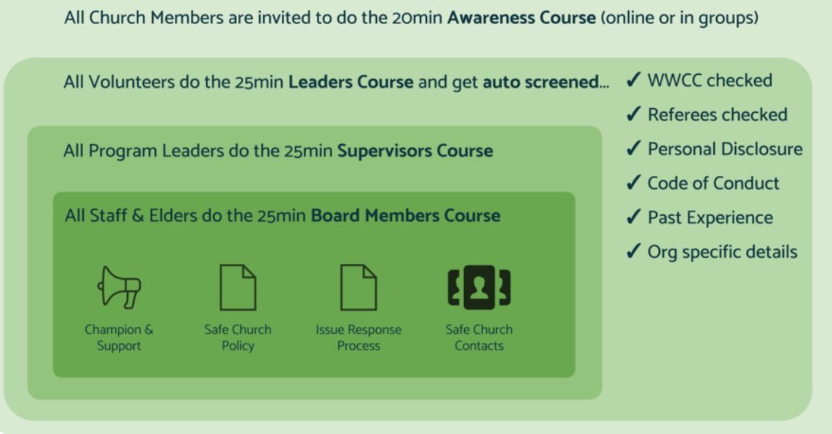
Diagram 1 – Visual explanation of safe ministry training modules www.safeministrycheck.com.au

Lighthouse Church, through our membership of the Fellowship of Independent Evangelical Churches (FIEC), is a member of the National Council of Churches in Australia (NCCA) safe ministry training agreement (SMTA). This allows our ministry workers to participate in Safe Church workshops run by partner churches as outlined in the calendar on their website: www.ncca.org.au

5.3 Process for ministry workers teaching Special Religious Education (SRE) in schools

Lighthouse Church is approved by the Department of Education as a provider of SRE or ‘scripture’ in NSW schools. The screening and training process is the same for members authorised to teach SRE, however the Department also requires confirmation that Lighthouse Church has ‘a system of authorised initial and ongoing training for their teachers that includes training in classroom management and child protection issues’. Therefore, training for ministry workers in schools also involves:
- initial training to provide new teachers with an understanding of the regulations surrounding SRE, the cultural context in which we do SRE, basic skill training and orientation to the curriculum
- ‘buddying’ with an experienced SRE teacher
- classroom management training provided as formal or on the job training or a combination of both
- opportunities to share any difficulties and ideas amongst teachers and gain ongoing support.

Teachers must wear a name badge with the Lighthouse Church logo while on site, and their names must be included or added to the list of teachers provided to the Principle of the school at the start of the year.

The document 'Religious Education Implementation Procedures' provides important information including the responsibilities of all parties, approval and reporting obligations: http://www.curriculumsupport.education.nsw.gov.au/policies/religion/assets/pdf/implementation.pdf

5.4 Process for non-Lighthouse Church workers

On occasion Lighthouse Church may have help from children’s/youth ministry workers from other churches eg church weekend away, Summerfest. In some instances, visiting ministry workers may qualify for an exemption from screening if they are not ‘working’ for Lighthouse Church for more than 5 working days in a calendar year AND are supervised. Where an exemption does not apply, a WWC number and employer verification must be completed before the event. Refresher safe ministry training is incorporated into the induction and training process prior to Summerfest.
5.5 Maintaining currency

The Office of the Children’s Guardian monitors WWC clearances and will notify any organisation that has verified an individual if their clearance status changes (ie they commit serious sexual and/or violent offences).

WWC checks must be updated every 5 years. Safe ministry training must be repeated every 3 years at a minimum. Due dates are recorded in an online register with our safe ministry training provider. The safe ministry representative (SMR) monitors due dates and emails ministry workers a training invitation and/or instruction sheet to renew their WWC clearance ideally with a 2-3 weeks’ notice. If no response is received by the due date, the SMR emails the person and the ministry leader to advise they are no longer able to perform child related work. From this point, responsibility lies with the ministry leader and pastor overseeing ministry to ensure the person completes their training / WWC check before the next serving date.

Lighthouse Church’s LC04 – serving in children’s and youth ministry document is provided for ministry workers on commencement, and every three years at a minimum when safe ministry training is updated. The safe ministry representative is responsible for ensuring content is regularly updated, refined, and expanded to reflect current practices and expectations.

Addressing concerns, suggestions, and non-reportable conduct

The best protection against any issues in children’s ministry is prevention and communication. Lighthouse safe ministry procedures aim to prevent situations that may compromise the care of children or give rise to concerns or complaints relating to care provision.

Children’s/youth ministry workers are instructed and trained in what to do if they receive a concern or complaint from parents, carers, or other people involved in church. The key message is that they relay the information and/or refer the matter to their ministry leader who will make decisions about how the it matter should be managed. These concerns or complaints relate to the day-to-day processes or events that are expected in ministry. It may reflect parent or caregiver preferences or expectations, and may provide the opportunity for improvements in our systems and processes.

Some matters may relate to the safety and wellbeing of children in our care, but do NOT involve any suggestion of inadequate or inappropriate behaviour by ministry workers or church as a whole, and do not present a risk of significant harm to children. In this instance the ministry leader would generally manage these matters directly with those involved. The leader may seek input, support or advice from others (eg senior pastor or safe ministry representative) in addressing or resolving the situation, particularly if it may require actions by others in church, or a change in procedures or practices. If a leader is unsure whether an issue warrants escalation - it should be raised with the Safe Ministry Representative or Senior Pastor.

Addressing unacceptable or reportable conduct

Church has obligations to report to NSW government Departments or Agencies:
- allegations of conduct that is unacceptable or may be ‘reportable’ conduct by a Lighthouse Church ministry worker, or
- where there are reasonable grounds to conclude a child may be at risk of significant harm or abuse
- any criminal allegation.

Ministry workers and leaders have a legal obligation to report unacceptable or reportable behaviour with or in the presence of a child including alleged conduct by other ‘employees’. OCG advises workers to report any ‘allegation, disclosure, complaint, concern, incident or observation involving alleged misconduct of a [Lighthouse Church] worker (including volunteers and contractors) with, towards or in the presence of a child. This recognises it may be difficult for a ‘worker’ to determine if the matter is reportable and allows the decision to be made by those who are more familiar with the definition and legislative requirements.

Ministry workers and leaders are instructed and trained in how to receive and respond to a disclosure by a child, and how to report any concerns about misconduct with or in the presence of a child. The following process outlines the steps the Safe Ministry Representative and/or Senior Pastor will take to ensure we meet our reporting obligations. This process is depicted in the diagram below.

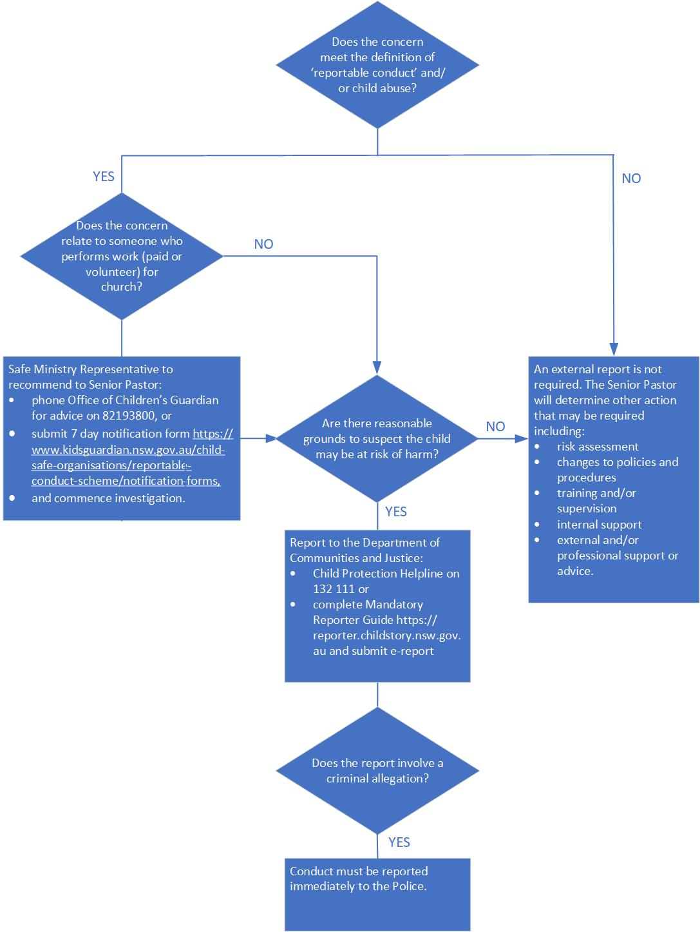

Diagram 1 – Process for determining reporting requirements when an allegation is made

  - Does the concern meet the definition of ‘reportable conduct’ and/or child abuse?

The Children’s Guardian Act 2019 defines reportable conduct as:
- a sexual offence (eg touching, grooming, possession of child abuse material)
- sexual misconduct (conduct towards or in the presence of a child that is not an offence including sexual comments, or suggestions to a child to act in a sexual manner)
- ill-treatment of a child (unreasonable, inhumane, cruel behaviour towards a child eg inappropriate forms of behavioural management)
- neglect of a child (significant failure to provide adequate care, or to protect from harm)
- an assault against a child (intentional or reckless application of physical force eg hitting, punching)
- behaviour causing significant emotional or psychological harm to a child
- an offence under s 43B (failure to protect) or s 316A (failure to report) of the Crimes Act 1900.
Child abuse is defined as any act resulting in actual or the likelihood of harm to a child’s health, survival, development or dignity in the context of a relationship of responsibility, trust or power. Abuse may be physical, sexual, psychological/emotional, ill treatment or neglect. Additional information on child abuse definitions, indicators and examples are included in LC04 – serving in children’s/youth ministry.

Reportable conduct does not include:
- conduct that is reasonable for the purposes of the discipline, management or care of children, having regard to the age, maturity, health or other characteristics of the children
- use of physical force that, in all the circumstances, is trivial or negligible.
Examples of conduct that would not constitute reportable conduct include touching a child to attract their attention, to guide a child or to comfort a distressed child, a teacher raising his or her voice in order to attract attention or to restore order in the classroom.

Enquiries can be made to the Reportable Conduct Directorate of OCG:
- enquiries line 02 82193800 (Mon-Fri) for advice and support
- reportableconduct@kidsguardian.nsw.gov.au

  - Does the concern relate to someone who performs work (paid or volunteer) for church?

Lighthouse Church is a ‘religious body’ which means we have obligations under the NSW Reportable Conduct Scheme which include reporting allegations of conduct that may be ‘reportable conduct’ by ‘employees’ to the Office of the Children’s Guardian (OCG).
In the context of the NSW Reportable Conduct Scheme, a person is considered an ‘employee’ if they:
- are a current paid employee of Lighthouse Church
- are a volunteer providing services to children on behalf of Lighthouse Church who holds, or is required by church to hold, a WWC clearance [for ‘child related work’]
- are a contractor who holds, or is required by Lighthouse Church to hold, a WWC clearance.

The Reportable Conduct Scheme is an allegation-based scheme. A reportable allegation is an allegation that an employee has engaged in conduct that may be reportable conduct. The threshold for notifying the OCG is that a reportable allegation has been made – that is, there is an allegation that an employee has engaged in conduct that may be reportable conduct or that they are the subject of a conviction that is considered a reportable conviction. This obligation exists regardless of whether:
- there is evidence or not that the conduct occurred
- it is considered likely or unlikely that the allege conduct occurred
- the conduct resulted in harm
- the person is now an adult providing they were a child when the alleged conduct occurred.

If it is determined that the allegations of ‘reportable conduct’ involves an ‘employee’ with reference to the definitions above, the HRE must:
- assess and manage any identified risks (to children, staff and the ‘employee’ involved)
- notify the Office of the Children’s Guardian (OCG) of a reportable allegation within seven business days of becoming aware of the allegation by completing the online ‘7-day notification’ form located here: https://www.kidsguardian.nsw.gov.au/child-safe-organisations/reportable-conduct-scheme/notification-forms (penalties apply for not notifying within relevant timeframes)

Once a report is made, we then have an obligation to investigate the allegation and ‘make a finding’ based on evidence and ‘the balance of probabilities’ as to whether the conduct is ‘reportable conduct’. For further information on this process refer to the following OCG Fact sheets:
- Fact sheet 4 - Planning and conducting an investigation
- Fact sheet 5 - Recognising and managing conflicts of interest
- Fact sheet 6 - Keeping records
- Fact sheet 7 - Disclosing information to children, parents and carers
- Factsheet 8 - Making a finding of reportable conduct.

7.3 Are there reasonable grounds to conclude a child may be at risk of significant harm and/or abuse?

This consideration applies to ‘reportable conduct’ or child abuse by any person against or in the presence of a child. For ‘employees’ (paid or volunteer) of Lighthouse Church, this consideration and reporting obligation is in addition to reporting requirements under the NSW Reportable Conduct Scheme.

Pastors and people involved in providing ‘religion-based activities to children’ are mandatory reporters. Mandatory reporters must make a report to the Department of Communities and Justice (DJC) when they have reasonable grounds to suspect that a child (0-15 years) is at risk of significant harm, and those grounds arise in the course of, or from their work or role. It is not mandatory to report young people aged 16 to 17 years or unborn children. In this instance professional judgement should be used to determine whether a report is warranted. If the matter relates to a young person being homeless, it is necessary to obtain their permission before making a report.

At Lighthouse Church, ministry workers and leaders are required to report any potentially reportable conduct or related concerns to the Safe Ministry Representative or the Senior Pastor. The senior pastor and/or SMR will determine whether or not the circumstances meet the ‘tests’ or threshold for reporting with reference to the following definitions:

- Reasonable grounds
Reasonable grounds' means your concerns are well founded and based on information you know, or have received from a reliable source. A useful consideration is whether another person, when presented with similar information, would draw the same conclusion.
- Significant risk of harm
A child or young person is at risk of significant harm if the circumstances that are causing concern for the safety, welfare or well-being of the child or young person are:
- present to a 'significant extent’
- sufficiently serious to warrant response by a statutory authority, irrespective of a family's consent
- not minor or trivial and may reasonably be expected to produce a substantial and demonstrably adverse impact on the child.
Significance can result from a single act or omission or an accumulation of these.

If, based on the definitions above and the circumstances of the matter, the Senior Pastor (HRE) determines immediate intervention is required they will phone the NSW Child Protection Helpline on 132 111 (24 hours, 7 days a week) to seek advice and make a report if indicated.

If urgent action is not required, the SMR and/or Senior Pastor will utilise the Mandatory Reporter Guide located at https://reporter.childstory.nsw.gov.au inform decision making and submit an e-report to the Department of Communities and Justice if indicated. In all cases the report generated by the Guide should be retained for record keeping purposes.

If a ministry worker authorised to teach school-based ministry advises the senior pastor they believe a child they teach at school is at risk of significant harm, the senior pastor should inform the school Principal. In this instance the Principal has the overall responsibility for determining whether an external report is required.

Mandatory reporters are protected from liability for defamation and civil and criminal liability. A mandatory report does not breach professional ethics or amount to unprofessional conduct. Mandatory reporters are legally protected against retribution for making or proposing to make a report.

7.4 Does the conduct reported involve criminal allegations?

If the allegation involves criminal allegations/conduct against a child, the senior pastor must immediately report the matter to the Police in addition to reporting obligations above.

This concludes the decision-making process for external reporting that Lighthouse Church will follow if an allegation of misconduct, reportable conduct and/or child abuse is received.

7.5 Other considerations and actions

Seek professional advice

Given the infrequency and consequent limited experience with reporting, the Senior Pastor may choose to seek additional advice before proceeding to make an external report providing this does not significantly delay further action. This may include:
- Anglican Church Diocese of Sydney Professional Standards Unit (PSU)
As an affiliated church we can contact PSU Director (02) 9265 1514 or psu@sydney.anglican.asn.au
- FIEC recommendation in correspondence dated May 2014
If legal advice is required with respect to child protection and abuse matters it is suggested we consider Prolegis lawyers: www.prolegis.com.au Philip Gerber has recently joined the team and has broad experience in many fields of law and a particular speciality in professional standards and child protection matters, and in managing significant investigations/complaints. He spent many years heading up the Professional Standards unit of Sydney Diocese.

Notify our insurer

Where the Mandatory Reporting Guide confirms an external report is required, and the concern or allegation involves any suggestion of misconduct by a person in their role at church or by church as a whole, the senior pastor will advise Lighthouse Church’s insurer and provide a copy of the mandatory reporting tool report: EA Insurance email: info@eainsurance.com.au or phone: (03) 9890 6851. Advice, instructions and action recommended by the insurer should be documented and acted upon by the senior pastor as soon as possible.

Record keeping

Meticulous record keeping is essential particularly in relation to decision making and recommended actions. Correspondence relating to a reportable matter could be subpoenaed or requested by other means.

Internal action

As a priority, regardless of whether external reporting is required, the senior pastor will take necessary steps to ensure the safety of children and young people at Lighthouse Church based on the conduct/allegation. This will involve undertaking a risk assessment, and many require development and implementation of an appropriate action plan. Refer to OCG Factsheet 3 - Risk management following an allegation: https://www.kidsguardian.nsw.gov.au/child-safe- organisations/reportable-conduct-scheme/fact-sheets
OCG advise an ‘organisation should seek advice and input from a specialist external agency to undertake an independent case review where complaints involve sexual abuse, physical assault or other serious forms of abuse’. A review will inform necessary changes to safe ministry policies and procedures.
These reviews should include all staff to ensure improvements are communicated, understood and accepted at all levels of the organisation.

If allegation has been made against a Lighthouse Church ministry worker, action taken will be informed by instruction from relevant government agencies and authorities, relevant professionals and our insurer. It is likely this will include the person stepping down from children's/youth ministry and other leadership roles until the matter is investigated and a finding is made. Depending on the allegation and circumstances, Lighthouse Church will may engage an external person with the appropriate qualifications and experience to conduct any necessary investigation.

The senior pastor will determine what support is necessary for those involved in consultation with our insurer, relevant professionals, Safe Ministries, FIEC and our Board of Reference. The child and their family may require immediate specialist counselling or other support. The person who raised the allegation, and potentially the person against whom the allegation has been made (assuming they are a member or regular attendee of Lighthouse Church) may also require support. Support for each party will need to be tailored and distinctly separate. A clear protocol regarding confidentiality with reference to relevant legislation will be established in each case.

Procedures relating to a ‘person of concern’

A ‘person of concern (or interest)’ is someone who has been convicted, accused, is reasonably suspected of, or has admitted to child abuse or sexual offences. If a ‘person of concern’ is identified, or wishes to attend Lighthouse Church, a Safety Plan must be developed beforehand.

The Safety Plan will be developed in line with the Guidelines for parishes regarding persons of interest developed by the Sydney Anglican Diocese Professional Standards Unit which include a plan template https://safeministry.org.au/safety-plans/ and a nominated plan supervisor. Where possible the plan will be developed in collaboration with the person and anyone likely to have responsibilities under the plan. The plan will include a condition that the person is unable to serve in formal ministry at Lighthouse Church.

Lighthouse Church will also seek advice where necessary to ensure we appropriately balance child safety considerations, appropriate support and accountability for the person of interest, our legal and insurance obligations. This may include assistance from:
- Sydney Anglican Safe Ministry Professional Standards Unit, and/or
- FIEC’s Safe Ministry contact (Andrew Mitchell)
- EA Insurance.

Record keeping

Records retained

- Safe ministry register
Online register maintained by our training provider, the pastor overseeing ministry and Safe Ministry Representatives. Includes the following information for every person involved in children’s/ youth ministry:
- name and date of birth
- WWC number, date and outcome of components of screening process
- date of completion of safe ministry training
- due dates for screening and training.

- Personal contact information and ministry groups
- Maintained in Elvanto (online database)

- Records relating to concerns, issues, allegations
- Records relating to suggestions, and non-reportable concerns, issues or complaints received or raised by parents, carers, members or other attendees of Lighthouse Church will be retained.
- Comprehensive records of all allegations and actions including dates of relevant conversations, conclusions reached, and action taken will be maintained. This information may be subpoenaed and used in a court of law.

- Other documentation
- Attendance rolls, permission forms, incident report forms will be retained.

- Policies and procedures
- Safe ministry policies and procedures are updated to reflect changes and improvements in practice. This may happen at any time, however a formal review will be undertaken at least once annually.

- Annual report to Administration Committee
- A report relating to the requirements of this policy and procedure document will be included in the annual safe ministry report presented to the Administration Committee.

Related policy and procedures
- LC01 Policy and procedure - privacy and information management
- LC02 Policy and procedure – recruiting paid ministry workers
- LC04 - Serving in children's and youth ministry
- Safe ministry child safe policy
- Child safe code of conduct
- LC05 Policy and procedure – managing concerns in church
- LC07 Policy and procedure - work health and safety.

Appendix 1 – Child Safe Standards

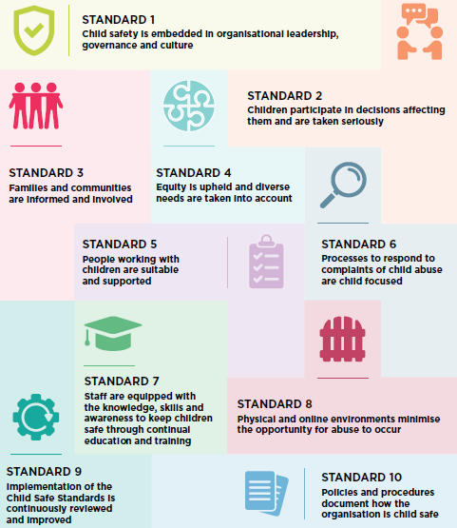

https://ocg.nsw.gov.au/organisations/reportable-conduct-scheme/reportable-conduct-fact-sheets
EA/ANSVAR Insurance Policy
Safe ministry (Youthworks) training manual
Breach of this legislative requirement may involve a fine or imprisonment for two years, or both.
Child Protection (Working with Children) Regulation 2013 Clause 20 Exemption from Act for specified workers and employers
http://safeministrytraining.com.au/
LC04 – serving in children’s and youth ministry document
Amendments to the Crimes Act 1900 mean it is an offence to for any person to know or believe a child abuse offence has been committed and fail to protect the child (section 43B failure to protect) or to report (section 316A failure to report) the conduct.
OCG Factsheet 9 - FAQ for employees provides information about obligations to report alleged conducts of other ‘employees’
LC04 – serving in children’s and youth ministry.
https://aifs.gov.au/cfca/publications/what-child-abuse-and-neglect
Section 41 of the Children’s Guardian Act 2019
The NSW Reportable Conduct Scheme was extended to include ‘religious bodies’ as of March 2020.
This obligation exists for a current paid employee whether the alleged conduct occurred in the course of, or in the period of, employment. There is no obligation to report alleged conduct of a previous employee.
OCG Fact sheet 1 - Identifying reportable allegations. https://www.kidsguardian.nsw.gov.au/child-safe- organisations/reportable-conduct-scheme/fact-sheets
Reportable Conduct Presentation. Office of the Children’s Guardian. Accessed Dec 2020: https://www.youtube.com/watch?v=O6D0-6nrhkc
As of March 2020, the definition of a ‘mandatory reporter’ under s27 of the Children and Young Persons (Care and Protection) Act 1998 includes an individual involved in ‘religious ministry or persons providing religion-based activities to children’.
Guide to making a child protection report. https://www.facs.nsw.gov.au/providers/children-families/interagency-guidelines/child-protection-report
https://reporter.childstory.nsw.gov.au/s/article/Significant-harm-policy-definition
Guide to the Child Safe Standards

