LC05 - Managing concerns in church
Introduction

God desires that his Church maintains unity and that love is pervasive. However, this side of heaven, we still wrestle with sin and disagreements and conflict will occur. God has much to say in the Bible about this. Sometimes concerns can be worked out between those involved - other times a more complex situation may require the assistance of others to help bring reconciliation and peace.

Scope

The primary audience for this document is members and staff of Lighthouse Church. In the context of church and this document, a ‘concern’ may involve a:
- conflict - disagreement or disharmony that affects a relationship between two or more people in church
- complaint - an expression of dissatisfaction with some aspect of how things were undertaken or performed providing an opportunity to address the issue
- dispute - an unresolved complaint that is escalated either within or outside of our organisation.
- grievance - formal complaint by a staff member about another staff member or a work-related problem.

An allegation is a concern that a legal obligation has not been met in the context of church. This might include for example an allegation of misconduct, child abuse or other form of criminal conduct. This document does NOT include managing allegations. In these instances you should promptly refer your concerns to the:
- Senior Pastor or
- Safe Ministry Representative where the allegation involves behaviour towards children (under 18).

References

Our process for managing concerns in church is based on the following resources:
- Peacemaker principles http://www.peacewise.org.au/get-help-with-conflict-2/peacemaking-principles/
- Fellowship of Independent Evangelical Churches (FIEC) Complaints Policy. 2020.
- Complaints-handling: model policy and procedure. Not-for-profit Law at Justice Connect promoted by the Australian Charities and Not-for-Profit Commission (ACNC) https://www.acnc.gov.au/tools/templates/complaints-handling-model-policy-and-procedure
- Grievance policy and procedure. Anglican Church Diocese of Sydney. July 2011. http://sydneyanglicans.net
- Complaint Handling Guide: Upholding the rights of children and young people. National Office for Child Safety. Australian Government.

Procedure

The information below outlines the process for raising, escalating and managing concerns in church.

Addressing concerns yourself
There may be times when you might be upset or hurt by something that has been said, or be concerned about someone’s behaviour and the impact of that behaviour. The peacemaking principles (see References) provides biblical guidance for preparing to talk with someone privately and lovingly about a matter – about seeking counsel, the steps involved in biblical negotiation, how to make an apology, and how to manage when the other person doesn’t respond as you hoped or expected.

The bible encourages us to raise concern directly with the person involved where it is possible (Matt. 18:15-17). However, there are times when this is not possible, or may not be appropriate due to the seriousness of the matter. In this instance, consider getting help from those in church.

Addressing concerns with the help of church

  - Seek counsel

There may be times when it is necessary to address a concern, but you don’t feel you can do this directly with the other person because:
- of the level of concern or upset a matter has caused you
- you are worried about how the person may respond
- of the nature of your concern
- of the role the other person holds in church
- you have tried to address the matter directly and were unsuccessful in resolving the matter.

In this case, consider getting help from a relevant leader in church. If the matter relates to a person on your ministry team, you might seek counsel from your ministry leader. If the matter involved a person in your growth group, you might seek input from your growth group leader. If the matter relates to a staff member, a relevant leader may be your growth group or ministry leader, a member of the selection panel or another member of staff.

Discussions with a relevant leader may result in the following:
- A decision to take no further action
- A decision that you should raise the matter directly with the person
- A decision to go together and raise the matter with the person (informal mediation)
- A decision that the matter should be escalated to church leadership.

  - Church leadership

If we are unable to resolve a matter on our own, God commands the local church to bring its wisdom, resources and authority to address the problem (Matt 18:16-20, Phil 4:2-3, 1 Cor 6:1-8). There are two avenues for seeking further consideration or input. In agreement with your relevant leader, you may choose to discuss your concern with a member of staff, or a member of the selection panel if your concern involves a member of staff.

You can expect discussion with any church leadership representative will align with biblical peacemaking principles. The role of the church representative is to act objectively and impartially and act in line with what is best for both people and for church. As part of the discussion the church leadership representative will talk with you about:
- appropriate options for addressing the matter
- your role in the process
- issues (and limitations) regarding confidentiality.

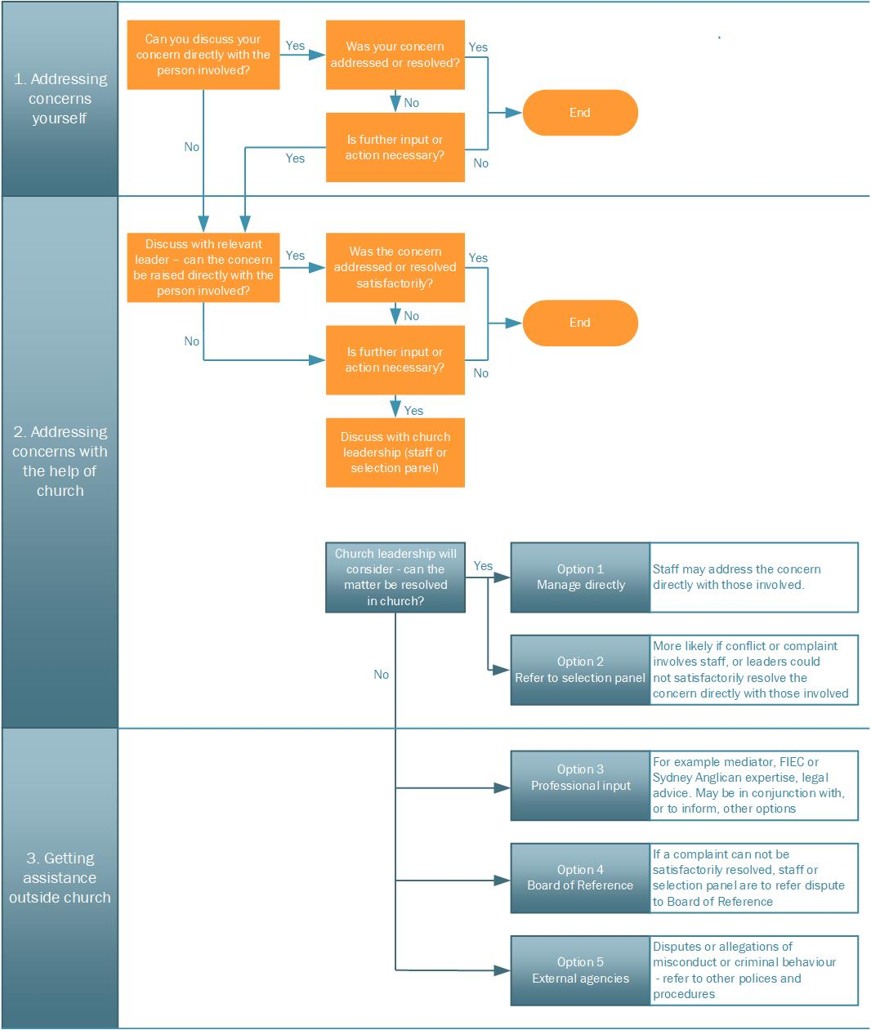

Diagram 1 - Process for managing concerns in church

The process in Diagram 1 above is split into an orange path (top), and a blue path (bottom). Up to the point where the matter is escalated to church leadership, the person who raised the concern is usually involved in how the matter should be addressed with support from others. However when a matter is escalated to church leadership, in recognition of significance of the concern, decisions regarding further action will primarily be made by leaders.

Church leadership representatives (pastors or selection panel members) have options for progressing a matter in church including:
- Manage directly
Leaders may choose to go again with you (or perhaps a relevant leader) directly to the person involved with the hope of resolving the matter, particularly if the concern primarily relates to a relationship between two people.

- Refer to selection panel
The staff or selection panel member may seek the counsel and involvement of the selection panel, particularly if the concern involves a member of staff. Church leadership may also seek input from members in church who have expertise in a particular area or are responsible for leading particular areas in church.

Getting assistance outside church

There may be times where it is necessary to seek wisdom, expertise and assistance outside Lighthouse Church. This may include the following options:

3.1 Professional input
This may include for example a professional mediator, or legal advice. It is likely these options will inform and be part of the broader process for resolving a matter in church.

3.2 Board of Reference
Staff or the selection panel may decide a matter should be referred to our Board of Reference. Additionally our church constitution requires disputes (unresolved complaint) between members, or between members and church, to be referred to our external Board of Reference for mediation.

3.3 External agencies
When a complaint is finalised, those involved will be advised of options for escalating a dispute with relevant external agencies for example the ACNC. The ACNC and other external agencies will usually only get involved in an internal dispute if there is a serious risk to public trust and confidence or a breach of the obligations to the agency.

If at any stage a concern raised in church involves the safety or welfare of a child or vulnerable person, the matter must be managed under a different process. Members and ministry workers should refer to LC04 – serving in children’s and youth ministry. Leaders responsible for evaluating and managing the concern, including whether there is an immediate need for mandatory external reporting, should refer to LC03 Policy and procedure – managing safe ministry in church for more detailed information to guide this process.

More information
For more information about any aspect of this document email admin@lighthouse.net.au

A separate document, LC06 Policy and Procedure – managing complaints, available on our website. The primary audience for this document is those external to church wanting to know how we manage complaints, or wanting to make a complaint.
Complaints-handling: model policy and procedure, developed by Not-for-profit Law at Justice Connect and promoted by the Australian Charities and Not-for-Profit Commission https://www.acnc.gov.au/tools/templates/complaints-handling-model-policy-and-procedure
https://www.acnc.gov.au/raise-concern/concerns-about-charities/dealing-internal-disputes

